Types of Stands
Peninsula

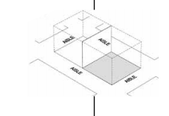 | Peninsula Stands – These are stands which are open on three sides with one full back wall, and back on to either another peninsula stand, or two lines of stands. The standard height of 2.5m (8ft) is allowed along the back wall and each side (if applicable – please see 3.3 OPEN FRONTAGES/SOLID WALLS). Enclosing walls (i.e. directly onto the aisle) are restricted to up to 50% of the length of the side of the booth and should be made to look interesting from the aisle and neighbouring booths.  You may display hanging signs, logos and graphics if they are set back 1.0 meters from any side, and you have gained permission from the Organiser. No advertising or logos should directly overlook any neighbouring stand.

